SDD Hydronic Pumping Configurations
11/5/2013

References/Credits:
Diagrams of “Actual” systems taken from the following references:
PG&E CoolToolsTM Chilled Water Plant Design and Specification Guide, May 2000
Taylor S., Optimizing Design & Control Of Chilled Water Plants Part 1: Chilled Water Distribution System Selection, ASHRAE Journal, July 2011

Primary Only, Single Chiller, Constant or Variable Flow

Option 1a) Constant speed pump

Actual
- Primary pump can be constant or variable speed.
- Pump operation interlocked with chiller operation.
- Three-way valves modulate between full flow and full bypass to maintain full flow regardless of coil demands.

SDD
- Supply-side Chlr object reference the PrimarySupply and PrimaryReturn FluidSeg objects via EvapIn/Out reference properties.
- Primary pump assigned as child of FluidSeg:Type = PrimaryReturn (Figure 1a-2) -or- as child of Chlr (Figure 1a-2). Pump:Cnt represents one or more equally sized pumps piped in parallel (headered pumps). Properties to define pump staging not currently defined in SDD.
- For Primary-only systems, demand-side coils attached to PrimarySupply and PrimaryReturn via FluidSegIn/Out reference properties. Coils have three-way valves (not explicitly defined in SDD).

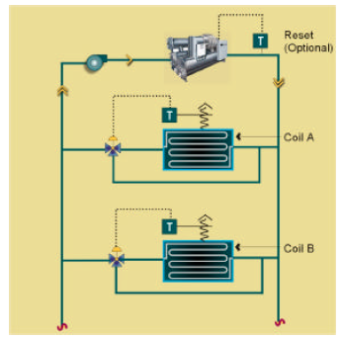
Actual 1a

FluidSeg
Type = PrimaryReturn
Chlr
HasBypass = 0
FluidSeg
Type = PrimarySupply
Pump
SpdCtrl = ConstantSpeed
Cnt = 1
SDD 1a-1

FluidSeg
Type = PrimaryReturn
Chlr
EvapHasBypass = 0
FluidSeg
Type = PrimarySupply
Pump
SpdCtrl = ConstantSpeed
Cnt = 1
SDD 1a-2

Option 1b) Variable speed pump

Actual
- For variable speed pumping, two-way valves are installed at most coils with just enough three-way valves installed to maintain the minimum flow required.

SDD
- Same as 1a-1 or 1a-2 except pump is SpdCtrl = VariableSpeed and coils have two-way valves (not explicitly defined in SDD).
- Chiller should have a bypass defined, a single bypass pipe assumed to be present in parallel to chiller.

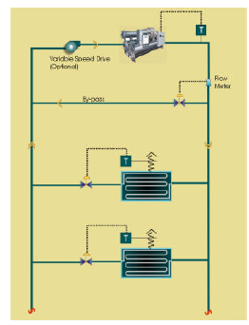
Actual 1b

FluidSeg
Type = PrimaryReturn
Chlr
EvapHasBypass = 1
FluidSeg
Type = PrimarySupply
Pump
SpdCtrl = VariableSpeed
Cnt = 1
Bypass
SDD 1b

Primary only, Multiple Parallel Chillers, Constant or Variable Flow

Option 2a: Constant speed pump(s) on primary loop

Actual
- If one chiller is OFF, flow still continues through the down machine unless a bypass is provided (shown as dashed line).
- Coils have three way valves to maintain constant flow rate.

SDD
- Supply-side Chlr objects reference the FluidSeg:Type = PrimaryReturn and PrimarySupply objects via EvapIn/Out reference properties.
- Primary pump assigned as child of FluidSeg:Type = PrimaryReturn. Pump:Cnt represents one or more equally sized pumps piped in parallel (headered pumps). Properties to define pump staging not currently defined in SDD.
- If any of the parallel chillers have bypass defined (HasBypass = 1), a single bypass pipe assumed to be present in parallel to chiller(s). Otherwise, flow passes through down chillers to maintain constant loop flow rates.
- For primary-only systems, demand-side coils attached to PrimarySupply and PrimaryReturn via CoilClg:FluidSegIn/Out reference properties. Coils have three-way valves (not explicitly defined in SDD).

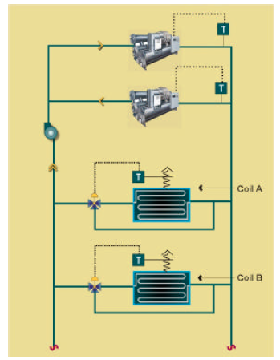
Bypass
Actual 2a

Chlr (1)
EvapHasBypass = 1 or 0
FluidSeg
Type = PrimaryReturn
Chlr (2)
EvapHasBypass = 1
FluidSeg
Type = PrimarySupply
Pump
SpdCtrl = ConstantSpeed
Cnt = 1+
Bypass
SDD 2a

Option 2b) Constant speed, dedicated chiller pumps

Actual
- Chiller pump OFF when chiller is OFF.
- Coils have three way valves to maintain constant flow rate.
- Works well if all coil loads change together.

SDD
- Same as 2a) except primary pumps assigned as children of each Chlr object.
- Bypass not needed since pumps are assumed to operate only when chiller operate

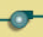
Actual 2b
Chlr (1)
EvapHasBypass = 0
FluidSeg
Type = PrimaryReturn
Chlr (2)
EvapHasBypass = 0
FluidSeg
Type = PrimarySupply
Pump
SpdCtrl = ConstantSpeed
Cnt =1
Pump
SpdCtrl = ConstantSpeed
Cnt = 1
SDD 2b

Option 2(c): Variable speed pump(s) on primary loop

Actual
- This represents the traditional, primary-only, variable flow pumping configuration.
- Chiller typically needs a bypass to maintain minimum flow through operating chillers.

SDD
- Same as 2a) except primary pump(s) are SpdCtrl = VariableSpeed and coils have two-way valves (not explicitly defined in SDD).
- At least one of the chillers should be defined with EvapHasBypass = 1.

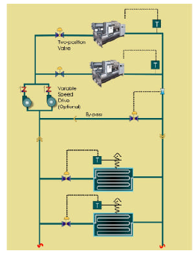
Actual 2c

Chlr (1)
EvapHasBypass = 1 or 0
FluidSeg
Type = PrimaryReturn
Chlr (2)
EvapHasBypass = 1
FluidSeg
Type = PrimarySupply
Pump
SpdCtrl = VariableSpeed
Cnt =1
Bypass
SDD 2c

Option 2d) Variable speed pumps interlocked to chiller

Actual
- Chiller pump OFF when chiller is OFF.
- Coils have two way valves.
- A bypass is required to maintain minimum flow through operating chillers.

SDD
- Similar to 2b) except primary pumps are variable speed.
- At least one of the chillers should be defined with EvapHasBypass = 1.
Actual 2d

Chlr (1)
EvapHasBypass = 1 or 0
FluidSeg
Type = PrimaryReturn
Chlr (2)
EvapHasBypass = 1
FluidSeg
Type = PrimarySupply
Pump
SpdCtrl = VariableSpeed
Cnt =1
Pump
SpdCtrl = VariableSpeed
Cnt = 1
Bypass
SDD 2d

Primary/Secondary, Single or Multiple Chillers
(Single chiller configuration not included)

Option 3(a): Constant or variable speed primary pump(s) on primary loop

Actual
- Primary loop pumps staged or have variable speed. Here, the bypass acts as the common pipe.

SDD
- Supply-side Chlr objects reference the FluidSeg:Type = PrimaryReturn and PrimarySupply objects via EvapIn/Out reference properties.
- Primary pump assigned as child of FluidSeg:Type = PrimaryReturn. Pump:Cnt represents one or more equally sized pumps piped in parallel (headered pumps). Properties to define pump staging not currently defined in SDD.
- At least one of the parallel piped chillers should have bypass defined (HasBypass = 1). The bypass in this case acts as the common pipe between the primary and secondary pumping loops.
- The relationship between primary and secondary FluidSegs is defined by the FluidSeg:PriSegRef property.
- Demand-side coils attached to SecondarySupply and SecondaryReturn via CoilClg:FluidSegIn/Out reference properties. Coils have two-way valves (not explicitly defined in SDD).
- Secondary pump assigned as child of FluidSeg:Type = SecondarySupply. Pump:Cnt represents one or more equally sized pumps piped in parallel (headered pumps). Properties to define pump staging not currently defined in SDD.

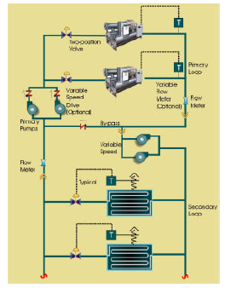
Actual 3a

Chlr (1)
EvapHasBypass = 1 or 0
FluidSeg
Type = PrimaryReturn
Chlr (2)
EvapHasBypass = 1
FluidSeg
Type = PrimarySupply
Pump
SpdCtrl = ConstantSpeed or VariableSpeed
Cnt = 1+
FluidSeg
Type = SecondarySupply
PriSegRef = PrimarySupply
FluidSeg
Type = SecondaryReturn
PriSegRef = PrimaryReturn

Bypass = Common Pipe
Pump
SpdCtrl = VariableSpeed
Cnt = 1+
SDD 3a

Option 3(b): Constant speed primary pumps interlocked to chiller

Actual
- Basically the same as Actual 3a, except the pumps are located on separate branches of chillers, and are interlocked to chiller operation.

SDD
- Same as SDD 3a, except individual primary pumps are defined as children of each Chlr object.
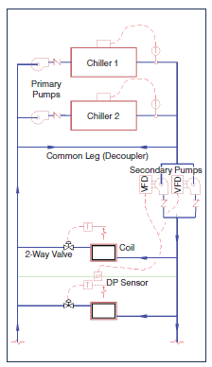
Actual 3b
Chlr (1)
EvapHasBypass = 1
FluidSeg
Type = PrimaryReturn
Chlr (2)
EvapHasBypass = 1
FluidSeg
Type = PrimarySupply
FluidSeg
Type = SecondarySupply
PrimSegRef = PrimarySupply
FluidSeg
Type = SecondaryReturn
PriSegRef = PrimaryReturn
Bypass = CommonPipe
Pump
SpdCtrl = VariableSpeed
Cnt = 1+
Pump
SpdCtrl = ConstantSpeed
Cnt = 1
Pump
SpdCtrl = ConstantSpeed
Cnt = 1
SDD 3b

Primary only or Primary/Secondary, Multiple Series Chillers

Option 4a) Primary pump(s) on primary loop

Actual
- Chillers piped in series. If chillers do not have bypass/isolation valves, pump primary flow assumed to pass through non-operating chillers.

SDD
- The first Chlr object in series on the supply-side references the FluidSeg:Type = PrimaryReturn object via EvapIn reference property.
- The last Chlr object in series on the supply-side references the FluidSeg:Type = PrimarySupply object via EvapOut reference property.
- Intermediate chillers in series are connected via references to FluidSeg:Type = Connector object. The upstream Chlr:EvapOutRef and downstream Chlr:EvapInRef properties of adjacent chillers both reference the same Connector object. More than two chillers can be connected in series, but each additional series chiller requires another FluidSeg:Type = Connector object.
- Primary pump assigned as child of FluidSeg:Type = PrimaryReturn. Pump:Cnt represents one or more equally sized pumps piped in parallel (headered pumps). Properties to define pump staging not currently defined in SDD.
- If any of the parallel chillers have bypass defined (EvapHasBypass = 1), a single bypass pipe assumed to be present in parallel to chiller(s). Otherwise, flow passes through downstream chiller(s) to maintain constant loop flow rates. Separate bypasses for individual chillers is not explicitly supported.
- For primary-only systems, demand-side coils attached to PrimarySupply and PrimaryReturn via FluidSegIn/Out reference properties. Coils have three-way valves (not explicitly defined in SDD).

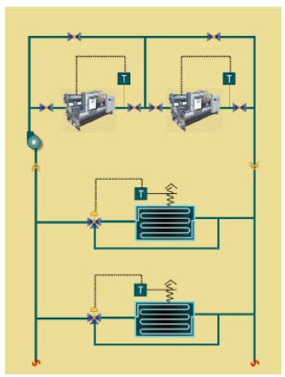
Actual 4a

Chlr (2)
EvapHasBypass =
1 or 0
FluidSeg
Type = PrimaryReturn
Chlr (1)
EvapHasBypass =
1 or 0

FluidSeg
Type = PrimarySupply
Bypass
Pump
SpdCtrl = ConstantSpeed
Cnt = 1+
FluidSeg
Type = Connector
SDD 4a

Option 4b) Primary pumps interlocked to chiller

Actual
- Sames as Actual 4a except the pumps are located in series with chillers on separate branches, and all chillers share a common bypass.

SDD
- Same as SDD 4a, except individual primary pumps are defined as children of each Chlr object.

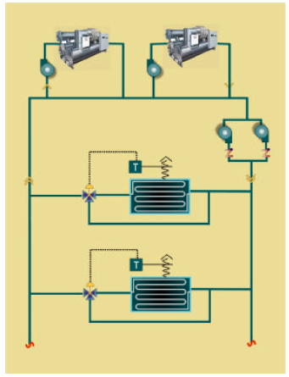
Actual 4b

Chlr (2)
EvapHasBypass = 1
FluidSeg
Type = PrimaryReturn
Chlr (1)
EvapHasBypass = 1
FluidSeg
Type = PrimarySupply
Bypass
Pump
SpdCtrl = ConstantSpeed
Cnt = 1
FluidSeg
Type = Connector
Pump
SpdCtrl = ConstantSpeed
Cnt = 1
SDD 4b

Primary/Secondary Variable Flow Piping, Tertiary Pumping

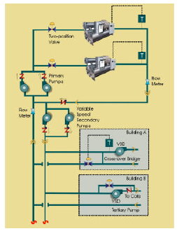
Actual 5a

SDD definition not defined yet, but will basically be the same as 3a or 3b, with additional FluidSeg:Type = SecondarySupply/Return objects that represent the tertiary pumping loops. Instead of referencing the primary loops, the secondary FluidSeg objects would be referenced by the Tertiary objects via the PriFluidSegRef properties.

